Diwylliant: Barn, Profiad a Hunaniaeth
Culture: Opinion, Experience, and Identity

Rydym eisiau deall sut mae pobl yn diffinio ac yn profi diwylliant yn eu bywydau pob dydd.
Rydym yn casglu barn trigolion Ceredigion am ystyr diwylliant, eich cysylltiad ag ef, a’ch cyfranogiad mewn digwyddiadau diwylliannol.
Gyda’ch mewnbwn, gallwn wella ein dealltwriaeth o agweddau pobl tuag at ddiwylliant, ac yna llunio cynllun gweithredu i fynd i’r afael â’r bylchau a nodir, lle bo hynny’n bosibl.
Os oes gennych unrhyw gwestiynau, cysylltwch ag Elin Williams, y tîm Celf a Diwylliant, Cyngor Sir Ceredigion.
Ffôn: 01545 570881
E-bost: Elin.Williams2@ceredigion.gov.uk.

We want to understand how people define and experience culture in their everyday lives.
We are gathering the views of Ceredigion residents about the meaning of culture, your connection to it and your participation in cultural events.
With your input, we can improve our understanding of people’s attitudes towards culture and develop an action plan to address the gaps identified, where this is possible.
If you have any questions please contact Elin Williams, Art and Culture team, Ceredigion County Council.
Telephone: 01545 570881
Email: Elin.Williams2@ceredigion.gov.uk.

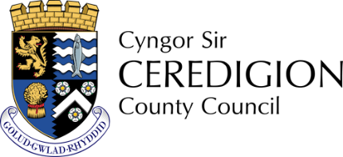
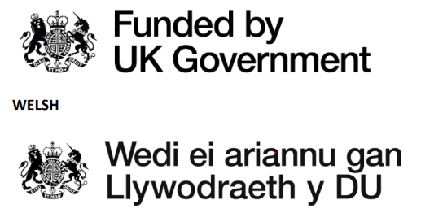

Os oes mwy nag un opsiwn i’r cwestiwn, ticiwch y blwch wrth yr ateb(ion) perthnasol os gwelwch yn dda.
If there is more than one option to the question, please tick the box next to the relevant answer(s).
- Oedran
Age
  - Dan 18 / Under 18
  - 18-30
  - 31-50
  - 51-70
  - Dros 70 / Over 70

- Ydych chi'n rhiant neu'n ofalwr i blentyn sy'n oed ysgol?
Are you a parent or carer of a school-aged child?
- Ydw/ Yes
- Na / No

- Os ydych — pa oedran yw’r plentyn/plant?
If so, what is the age of your child or children?

- Ydych chi’n llenwi’r holiadur hwn ar eich rhan eich hun, neu ar ran rhywun arall?
Are you completing this questionnaire for yourself, or on behalf of someone else?
- Ar rhan fy hun / For myself
- Ar ran rhywun arall / On behalf of someone else

- Os ydych chi’n ateb ar ran 'rhywun arall', a allwch chi egluro pwy?
If you are answering on behalf of 'someone else', please explain who they are.

- Ym mha bentref, dref, ardal yng Ngheredigion ydych chi'n byw?
In which village, town, area in Ceredigion do you live?

- Pa mor hir ydych chi wedi byw yng Ngheredigion?
How long have you lived in Ceredigion?
- Llai na blwyddyn / Less than 1 year
- 1-5 mlynedd / 1-5 years
- 6-10 mlynedd / 6-10 years
- 11-15 mlynedd / 11-15 years
- 16-20 mlynedd / 16-20 years
- Dros 20 mlynedd / Over 20 years
- Wedi byw yma drwy fy mywyd / Have lived here all my life

- Beth mae “diwylliant” yn ei olygu i chi?
What does “culture” mean to you?

- Pa agweddau o ddiwylliant sy’n bwysig i chi?
Which aspects of culture are important to you?
- Cerddoriaeth / Music
- Celf Weledol / Visual art
- Llenyddiaeth / Literature
- Theatr / Theatre
- Ffilm a ffotograffiaeth / Film and photography
- Treftadaeth a hanes / Heritage and history
- Iaith / Language
- Dathliadau cymunedol / Community celebrations
- Dawns / Dance
- Eisteddfod / Eisteddfod
- Arall / Other

- Os taw 'arall' eglurwch eich ateb isod
If 'other' please explain your answer below

- Trwy ba iaith mae’r digwyddiadau diwylliannol yr ydych chi'n mynychu fel arfer yn cael eu cynnal?
In which language are the culture events you usually attend delivered?
- Cymraeg / Welsh
- Saesneg / English
- Cymraeg a Saesneg / Welsh and English
- Arall / Other

- Os taw 'arall' eglurwch eich ateb isod
If 'other' please explain your answer below

- Pa mor aml ydych chi’n mynychu digwyddiadau diwylliannol yn eich ardal?
How often do you attend cultural events in your area?
- Yn rheolaidd / Regularly
- Yn achlysurol / Occasionally
- Prin iawn / Rarely
- Byth/ Never

- Beth sy'n eich rhwystro rhag mynychu digwyddiadau diwylliannol?
What prevents you from attending cultural events?

- Sut allai diwylliant gael ei hyrwyddo’n well yn eich cymuned?
How could culture be better promoted in your community?

- Pa mor bwysig yw gweithgareddau diwylliannol i chi?
How important are cultural activities to you?
- Pwysig iawn / Very Important
- Pwysig / Important
- Ddim yn bwysig / Not important
- Ddim yn gwybod / I don’t know

- Ydych chi’n teimlo bod diwylliant yn hygyrch i bawb yn eich cymuned?
Do you feel that culture is accessible to everyone in your community?
- Ydw / Yes
- Na / No
- Ddim yn siŵr / Not Sure

- Os wnaethoch ateb ‘Na’ neu ‘Ddim yn Siŵr’ i’r cwestiwn diwethaf, plîs defnyddiwch y blwch isod i esbonio pam.
If you answered ‘No’ or ‘Not Sure’ to the last question, please use the box below to explain why.

- Pa fath o weithgareddau neu brosiectau diwylliannol hoffech chi eu gweld yn eich ardal?
What kind of cultural activities or projects would you like to see in your area?

- Sut allai sefydliadau lleol (e.e. cynghorau, ysgolion, orielau, llyfrgelloedd) gefnogi diwylliant yn well?
How could local organisations (e.g. councils, schools, galleries, libraries) better support culture?

- Oes gennych chi unrhyw sylwadau neu syniadau pellach am ddiwylliant yn eich cymuned?
Do you have any further comments or ideas about culture in your community?

Dychwelyd yr Arolwg hwn
Diolch i chi am rannu eich barn gyda ni.
Gofynnwn yn garedig i chi ddychwelyd yr holiadur I’ch llyfrgell lleol neu trwy’r post erbyn y 12fed o Ionawr at:

Elin Williams, Tîm Celf a Diwylliant
Cyngor Sir Ceredigion, Penmorfa, Aberaeron SA46 0PA.

Am ragor o wybodaeth, cysylltwch â: Elin.Williams2@ceredigion.gov.uk.

Returning this Survey
Thank you for sharing your views with us.

Please return this questionnaire by the 12th of January to your local library or by post to:

Elin Williams, Art and Culture team
Ceredigion County Council, Penmorfa, Aberaeron SA46 0PA.

For more information, please contact: Elin.Williams2@ceredigion.gov.uk.

Diolch yn fawr.
Thank you.

