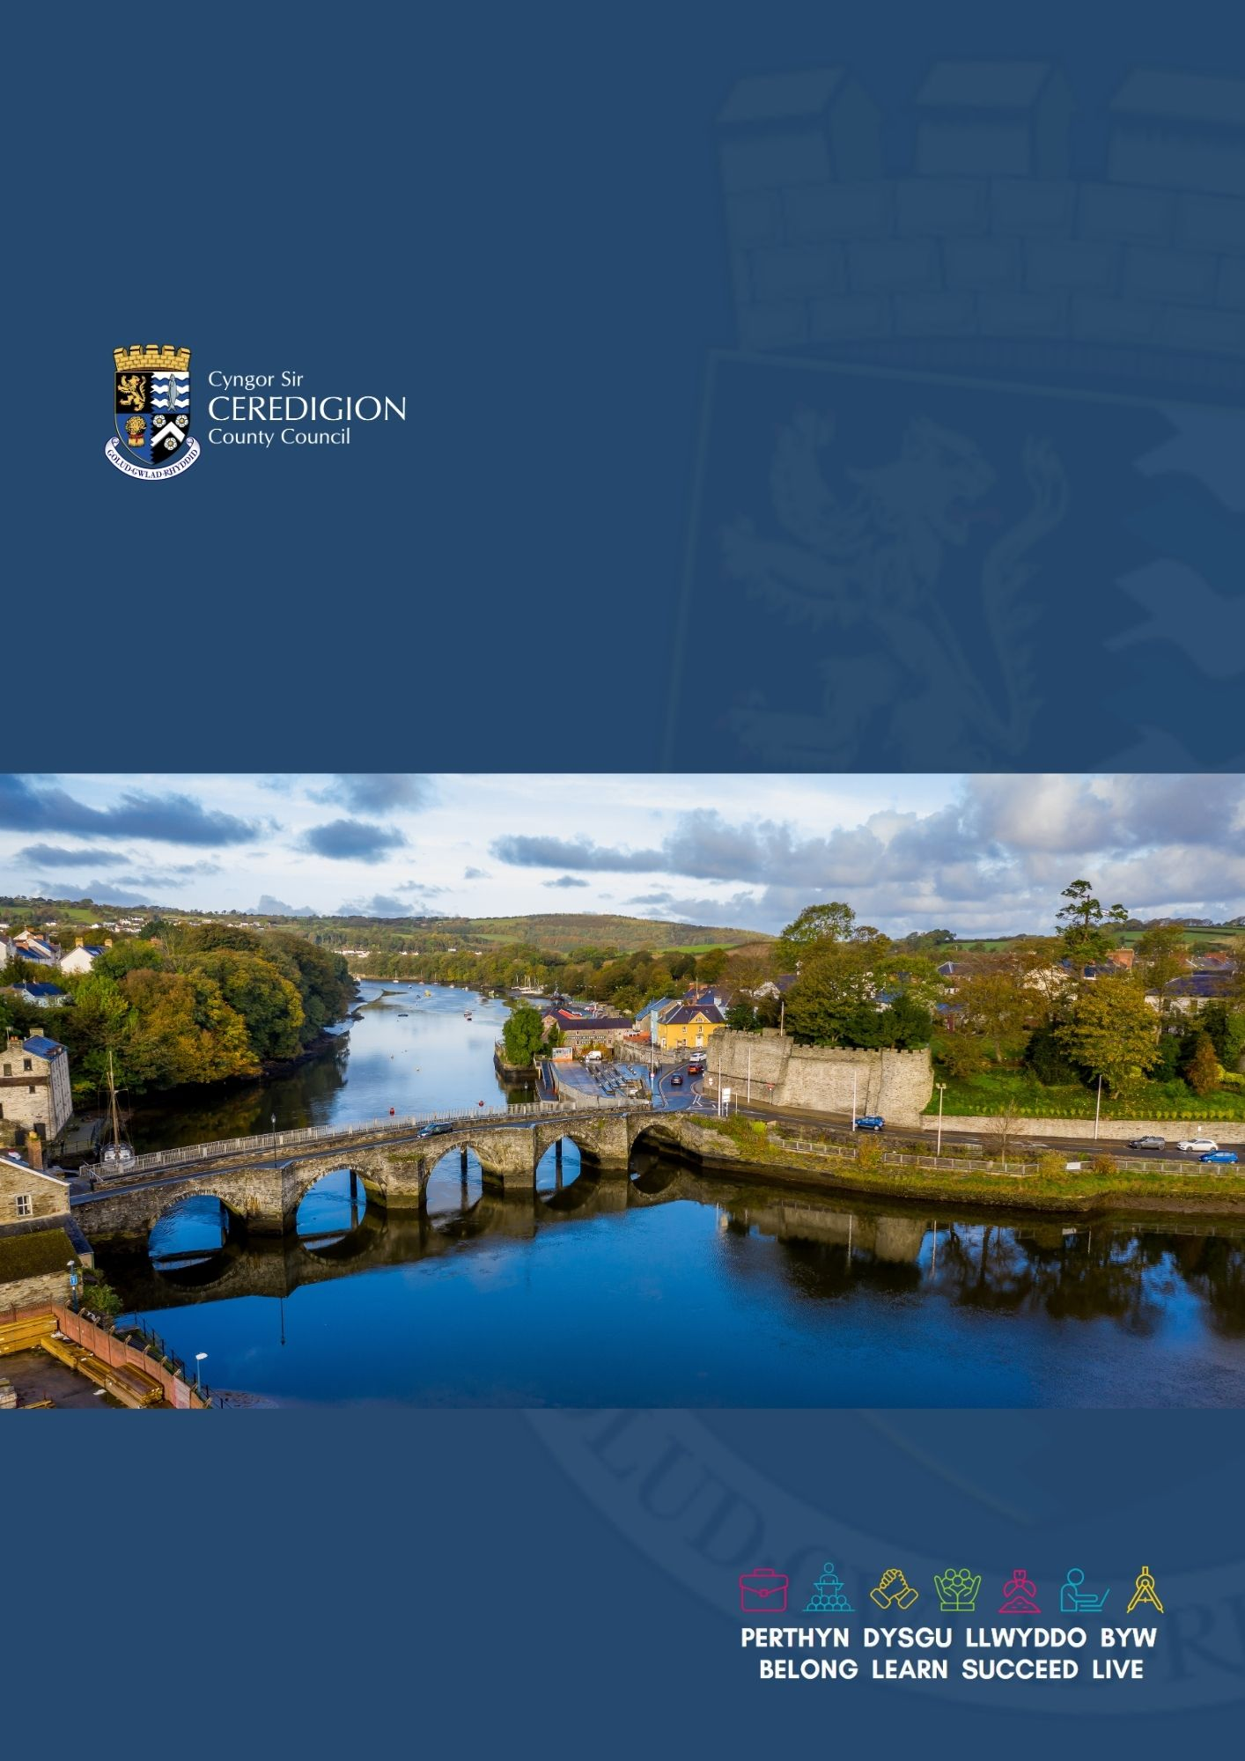

UAV / Drone Policy

Civil Contingencies Service
Version 4
17th November 2025

Contents

1. Introduction 2
2 Legislation 3
3 Training & Compliance 3
4 Data Handling 4
5 Privacy and Security 4
6 Appendix 5

Introduction

  - The purpose of this document is to outline a policy for the deployment and operational use of Unmanned Aerial Vehicles (UAVs), commonly referred to as drones, within Ceredigion County Council.

  - This policy aims to ensure that UAV technology is utilised in a lawful, ethical, and effective manner to support a range of local authority functions, with a particular focus on enhancing public safety, improving enforcement capabilities, and increasing operational efficiency.

  - The principal application of UAVs will be to support the prevention and enforcement of anti-social behaviour. This will include, but is not limited to:

- Conducting randomised, non-covert, high-visibility aerial patrols over designated anti-social behaviour hotspots, accompanied by prominent public signage to ensure transparency and awareness of monitoring and enforcement operations.

- Overt collection of evidence to support investigative actions.

- Aerial monitoring will also be used to reduce the need for staff to physically enter potentially hazardous or inaccessible premises or land. Thereby improving safety and efficiency.

  - UAVs will be deployed Overtly by the Authority to enhance operational effectiveness in the following areas:

- Public Space Protection Order (PSPO) Monitoring: Surveillance and enforcement of PSPO conditions

  - Statutory inspection and monitoring - Environmental and Trading Standards enforcement: Including detection of Illegal disposal of animal carcasses

  - Watercourse pollution

  - Licensing conditions

  - Abandoned dogs

  - Fly tipping and other illegal disposals

  - Breaches of local byelaws

  - Some other examples where we may develop our use of drones:

- Aerial - property and structural inspections (cost effective)
- Breaches of planning and permitted developments.
- Civil Contingencies
- Surveying
- Sports ground safety
- Events Safety monitoring of conditions
- Imagery for Marketing & Comms
- Traffic monitoring / planning.
- Public Safety Information broadcasting
- Parking enforcement

Legislation

  - To ensure the safe and lawful operation of UAVs, Ceredigion County Council will adhere to the legislation and guidance established by the UK Civil Aviation Authority (CAA).

There are associated levels of training and qualifications that apply to remote pilots. The primary reference document is Civil Aviation Publication (CAP) 722 – Unmanned Aircraft System Operations in UK Airspace, (Revision 9.2) see (Appendix 1) All Ceredigion staff Remote Pilots will comply with the CAA Policy and guidance in CAP 722 (9.2)
Unmanned Aircraft System Operations in UK Airspace - Guidance

  - Although the authorities use of Drones will be for Overt statutory monitoring and inspection purposes, Ceredigion County Council is committed to ensuring that all UAV operations will comply with the Regulation of Investigatory Powers Act 2000 (RIPA).

  - Where operations require further targeted or directed surveillance that falls under the Regulation of Investigatory Powers Act (RIPA), alternative methods will be considered.

- Training & Compliance

  - The established commercial standard for remote pilots operating UAVs within the UK is the General Visual Line of Sight Certificate (GVC). All remote pilots operating UAVs for the Authority must hold a GVC. This has enabled Ceredigion County Council, as an operational entity, to be issued with an Operational Authorisation the CAA.

  - A mandatory Operations Manual has been prepared by Council staff and approved by the Civil Aviation Authority (CAA). This document outlines all aspects of proposed UAV operations including:

- Public safety protocols
- Pre- and post-flight safety checks
- Remote Pilot training and certification
- Risk assessment procedures
- Technical specifications and maintenance requirements
- Flight logging and record-keeping

  - All UAV operations conducted by the Authority will strictly adhere to the procedures and standards set out in the Operations Manual. Compliance ensures that flights are conducted safely, legally and in accordance with CAA regulations.

  - The Operational Authority issued to Ceredigion County Council by the CAA for the commercial use of our drones sets limits which apply to all our drone operations:

- Maximum Take-off Weight (MTW) below 25kg.
- Operations within 150m of residential, commercial, industrial, or recreational areas.
- Pilots maintaining visual line of sight (VLOS).

  - To operate commercially our corporate insurance policy has been updated with the required coverage which complies with CAA regulations.

  - It is a condition of our corporate Insurance cover that we maintain compliance with the Operations Manual, remote pilot training and certification.

  - Additionally, an internal approval procedure will govern the purpose and use of deploying UAVs in the organisation and will to sit alongside the CAA Operations Manual. (see CCC UAV Authorisation Procedure)

These certification and compliance measures form a core component of the Council’s commitment to safe, lawful, and professional UAV operations.

Data Handling

  - Organisations using drones are controllers for any personal data that is captured. Ceredigion County Council policy is that we will comply with data protection law regarding capture of data by drones.

  - Any evidential product obtained will be treated in accordance with existing protocols regarding retention and use of digital media.

Collateral Intrusion

  - Any images or recordings not relevant to the purpose of the flight will be securely destroyed as soon as practicable.

Privacy and Security

Images and other Data Collection Requirements extracts from CAA CAP 722 v9.2

  - As a UAS operator Ceredigion County Council are aware that the collection of images of identifiable individuals, even inadvertently, when using surveillance cameras mounted on an unmanned aircraft, may be subject to the General Data Protection Regulation and the Data Protection Act 2018. As an Authority we are also bound by the Protection of Freedoms Act 2012.

  - Further information about these regulations and the circumstances in which they apply can be obtained from the Information Commissioner’s Office and website:
https://ico.org.uk/for-the-public/drones/.

  - A check list drawn from UAV guidance issued by the Information Commissioner’s Office (ICO) forms part of our standard operating procedures (SOPs).

  - As a UAV operator we are aware of our responsibilities regarding operations from private land and any requirements to obtain the appropriate permission before operating from a particular site. These factors are covered in the flight planning templates.

  - Remote Pilots must ensure that they observe the relevant trespass laws and do not unwittingly commit a trespass whilst conducting a flight.

  - A Drone/UAV Privacy Notice as well as this policy covering the use of drones by the authority will also be available to the public on the Council website.

  - All Remote Pilots when deploying drones will carry a hard copy of the UAV Privacy Notice and will display Data Privacy signs informing the public of how and where to access further information.

Providing Privacy Information
  - A key issue with using drones is that, on many occasions, individuals are unlikely to realise they are being recorded or be able to identify who is in control. As a controller, we must address the challenge of providing privacy information.
We achieve this by:

- Formally registering our drones with the Civil Aviation Authority (CAA)
- Placing signage in the area we are operating a drone explaining its use and arrangements for data access
- Having a privacy notice on our website that we can direct people to so individuals can access further information.

Appendix

Unmanned Aircraft System Operations in UK Airspace – Policy and Guidance –

Unmanned Aircraft System Operations in UK Airspace - Guidance

